

The 3th International Conference on the Flat Dilatometer

***Rome 15-17 June 2015***

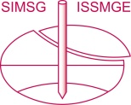 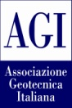 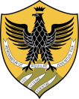

The Technical Committee TC-102 of the International Society of Soil Mechanics and Geotechnical Engineering (ISSMGE), the Italian Geotechnical Society (AGI) in cooperation with L'Aquila University are pleased to announce the 3rdInternational Conference on the Flat Dilatometer DMT'15 in Roma (Italy).

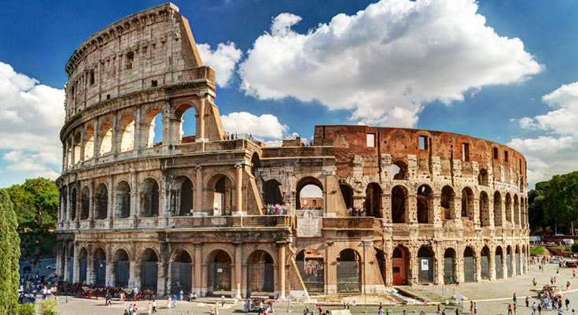

The previous two International Conferences on DMT were held in Edmonton Canada (1983) and in Washington D.C. (2006).

The 3rd International Conference on the Flat Dilatometer will be held June 15-17, 2015 at the  Parco dei Principi Grand Hotel & SPA  in Rome (Italy), steps away from Via Veneto, centre-stage of Fellini's Dolce Vita, overlooking Villa Borghese. Ancient Rome (Colosseum, Roman Forum etc etc) the Vatican and other sightseeing attractions are easily reached from the hotel.

The theme of the Symposium is the solution of geotechnical problems using the Flat Dilatometer Test (DMT), in particular settlement prediction and liquefaction evaluation. Other design applications include: compaction control, detecting slip surfaces in slopes, laterally loaded piles and other geotechnical problems using the soil parameters for which the DMT provides estimates.

Engineers, Consultants, Geologists, Researchers, Teachers and Students are invited to share their knowledge and experience. The technical and social program will provide an opportunity for meeting new contacts. The event will include an exhibition of equipments and services.



Further enquiries, sponsors, exhibitors to:

[info@dmt15.com](mailto:info@dmt15.com)

Abstracts max 1 page by July 15th 2014 to:

[papers@dmt15.com](mailto:papers@dmt15.com)

Official web site:

[www.dmt15.com](http://www.dmt15.com)